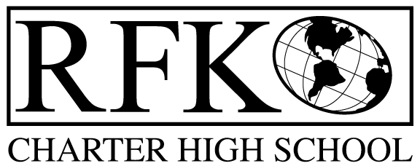

4300 Blake Rd. SW, Albuquerque, NM 87121
PHONE: 505-243-1118 FAX: 505-242-7444

Our Mission
The mission of Robert F. Kennedy Charter High School is to operate a public school that provides a safe, positive, supportive learning environment that considers each student’s individual learning style and level of skill development. Students will participate in an educational program with high expectations, mutual respect and community involvement that encourages and supports their mastery of the skills and knowledge required of high school graduates for the 21st century.

Governance Council Meeting Agenda
Date November 5, 2012 @ 5:30 pm

5 min Reading of RFK’s Mission Statement
5 min Approval of Agenda
5 min Approval of previous meeting Minutes
10 min Public Forum
10 min Staff / Student Presentations
Ervin Miller and Tim Hartman report on visit to Youthbuild program in Denver
Committee Reports:
5 min Audit Report
0 min Policy and Procedures (no report at this time)
10 min Finance Report and vote to approve
Vote on BAR(s)
5 min Discussion of By-laws update – Margie and Jennifer
10 min Committee assignments – clarify assignments (see October minutes)
10 min Nominations and Election of Treasurer, vote to select
Vote to add Treasurer signature to RFK School Account
10 min Executive Director Report (see attached)
5 min Governance member vote – Tina Garcia
5 min Discussion of November Retreat
10 min Conference debrief
15 min Discussion - Youthbuild at RFK
Adjournment

4300 Blake Rd. SW
Albuquerque, NM 87121
PHONE: 505-243-1118 FAX: 505-242-7444

PUBLIC NOTICE
OF
GOVERNANCE COUNCIL
BOARD MEETING

Robert F. Kennedy Charter High School will be holding their monthly Governance Council Board Meeting.

Date
Monday, November 5, 2012

Time
5:30 pm

Location
4300 Blake Rd. SW
Albuquerque, NM 87121

